**USE CASE DOCUMENTS**

## **1.Document information**

**Use case ID : UC**-1

**Use case name :** Submit complaint

**Actors :** Customer , System

**Brief Description** : This use case describe the steps a customer follows to submit a complaint using a web portal. The system captures the complaint and assign a unique ticket Id and forward it for resolution.

**Pre-Conditions :**

* Customer has internet access and can access complaint form
* The system is online and operational
* Required fields like (name, contact Info, complain description) in complaint form

**Post-Conditions :**

* Complaint should be saved in system database
* A unique ticket ID should generate
* Customer should notifies via SMS/email
* Complaint should assign to agent

**Basic Flow :**

|  |  |  |
| --- | --- | --- |
| **Step** | **Actor** | **Action** |
| 1 | Customer | Open the complaint submission portal |
| 2 | Customer | Fill the required details in form |
| 3 | Customer | Submit the form |
| 4 | System | Validate the submit fields |
| 5 | System | Generate unique ticket ID |
| 6 | System | Stores the complaint in database |
| 7 | System | Sends the confirmation message to customer |
| 8 | System | Queues the complaint for auto-assignment |

**Basic Flow Diagram :**

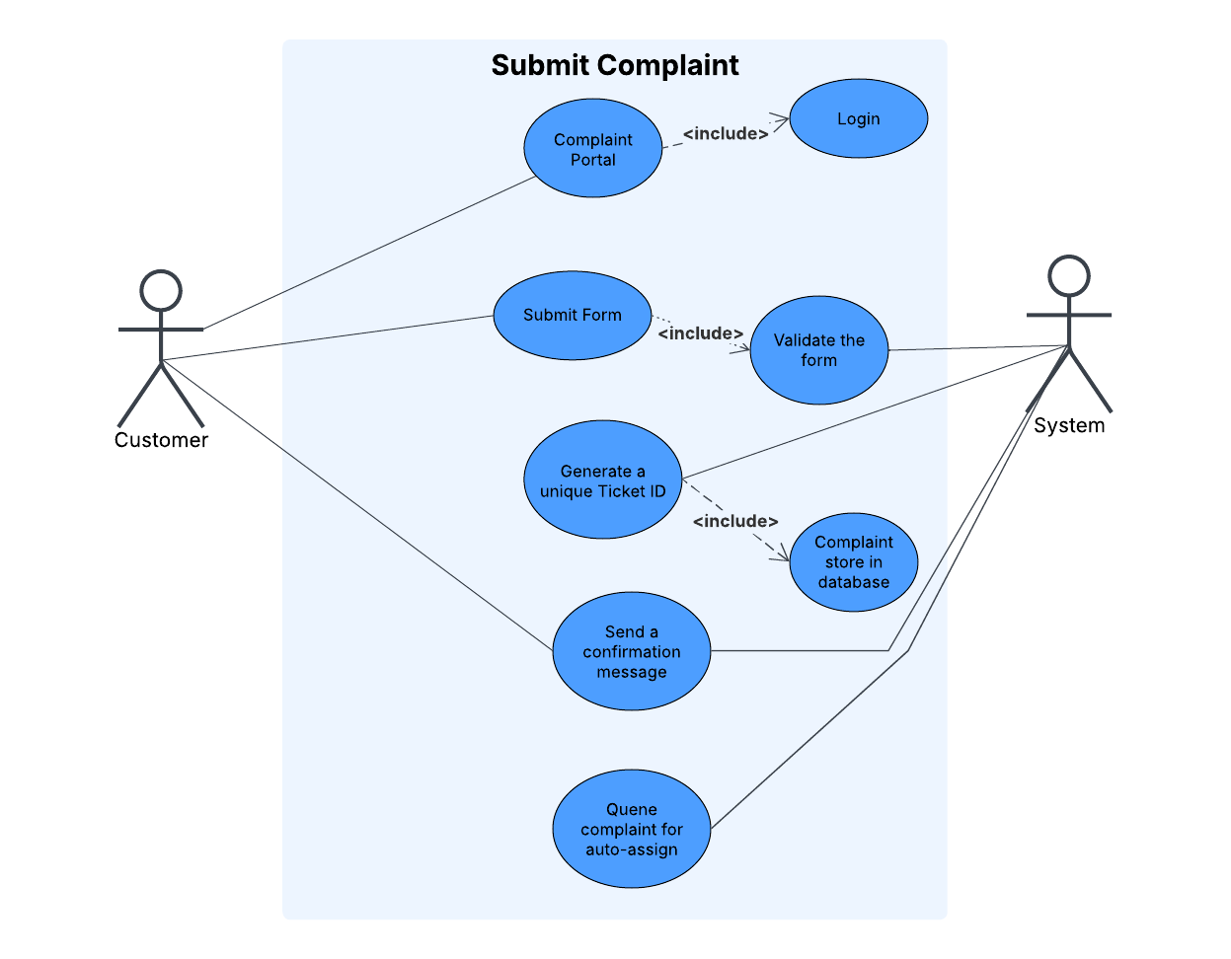

**Alternate Flow :**

* If customer doesn’t fill form mandatory fields, the system display an error message and back to form
* The customer is prompted to fill or complete all required fields prior re-submission

**Related functional requirements :**

* FR-1 : complaint submission via form
* FR-2 : unique ticket ID
* FR-3 : send confirmation message to customer

**Frequency of use :**

Several times per day by multiple users expected usage

**2.Document information**

**Use case ID :** UC-2

**Use case name :** Update complaint status

**Actors :** primary Actor : Support agent, Secondary Actor : System

**Brief Description** : This use case describe the steps how a agent interact with system to update complaints status (e.g., from “New” to “In progress”, “Resolved”, “Closed”) and trigger customer notifications.

**Pre-Conditions :**

* Agent is authenticated and logged in the system
* Agent has to be assign at least one complain
* Complain should exist in the with valid ticket ID

**Post-Conditions :**

* Complaint status is updated in system
* Timestamp and agent ID should be recorded
* Customer should be notifies via SMS/email regarding status

**Basic flow :**

|  |  |  |
| --- | --- | --- |
| **Step** | **Actor** | **Action** |
| 1 | Agent | Log into complain system |
| 2 | Agent | Navigate to the list of assigned complaints |
| 3 | Agent | Select any complaint using ticket ID |
| 4 | Agent | Choose any new status like “In progress’’ , “Resolved” |
| 5 | Agent | Add optional comment or notes to complaint |
| 6 | System | Validate user role and credentials |
| 7 | System | Update complaint status and logs timestamp |
| 8 | System | Sends notification to customer with updated status |

**Basic flow diagram :**

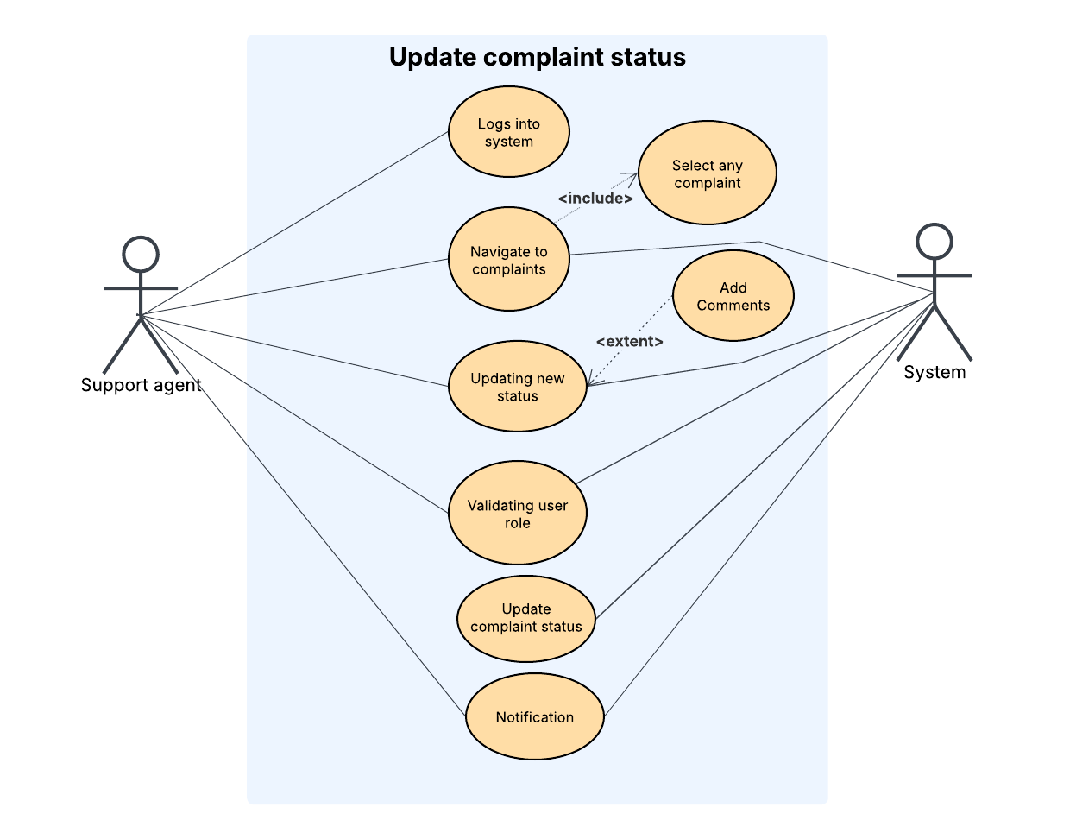

**Alternate Flow :**

* If complaint ticket ID is invalid or not found then system should display “complaint is not found”
* Status should not change until Agent change by itself like (“New” to “Closed”) directly

**Related functional Requirements:**

* FR-4 : Complaint management system
* FR-6 : feedback trigger after resolution
* NFR-3 : Role based access & security

**Frequency of use :**

Multiple times per day by Agent based on complain lists

**3.Document information**

**Use case ID :** UC-3

**Use case name :** View complaint dashboard

**Actors :** primary Actor : Manager, Secondary Actor : System

**Brief Description** : This use case describe the steps how a manager accesses the complaint management dashboard to monitor complaint statuses, identify areas for improvement, track agents speed and accuracy for feedback and track key performance indicators (KPI’s) for reporting.

**Pre-Conditions :**

* Manager is authenticated and has dashboard access rights
* The system should contain updated complaints data
* System should connected to reporting source

**Post-Conditions :**

* Manager can views the real time complaints data and agent performance
* Optionally export report or can have drill down feature.

**Basic flow :**

|  |  |  |
| --- | --- | --- |
| **Steps** | **Actors** | **Action** |
| 1 | Manager | Logs into system using credentials |
| 2 | Manager | Navigate to complaint dashboard |
| 3 | System | Authenticate user role and load dashboard components |
| 4 | Manager | View real-time metrics |
| 5 | Manager | Edit (applies filters) |
| 6 | Manager | Optional exports data for reporting |

**Basic Flow diagram :**

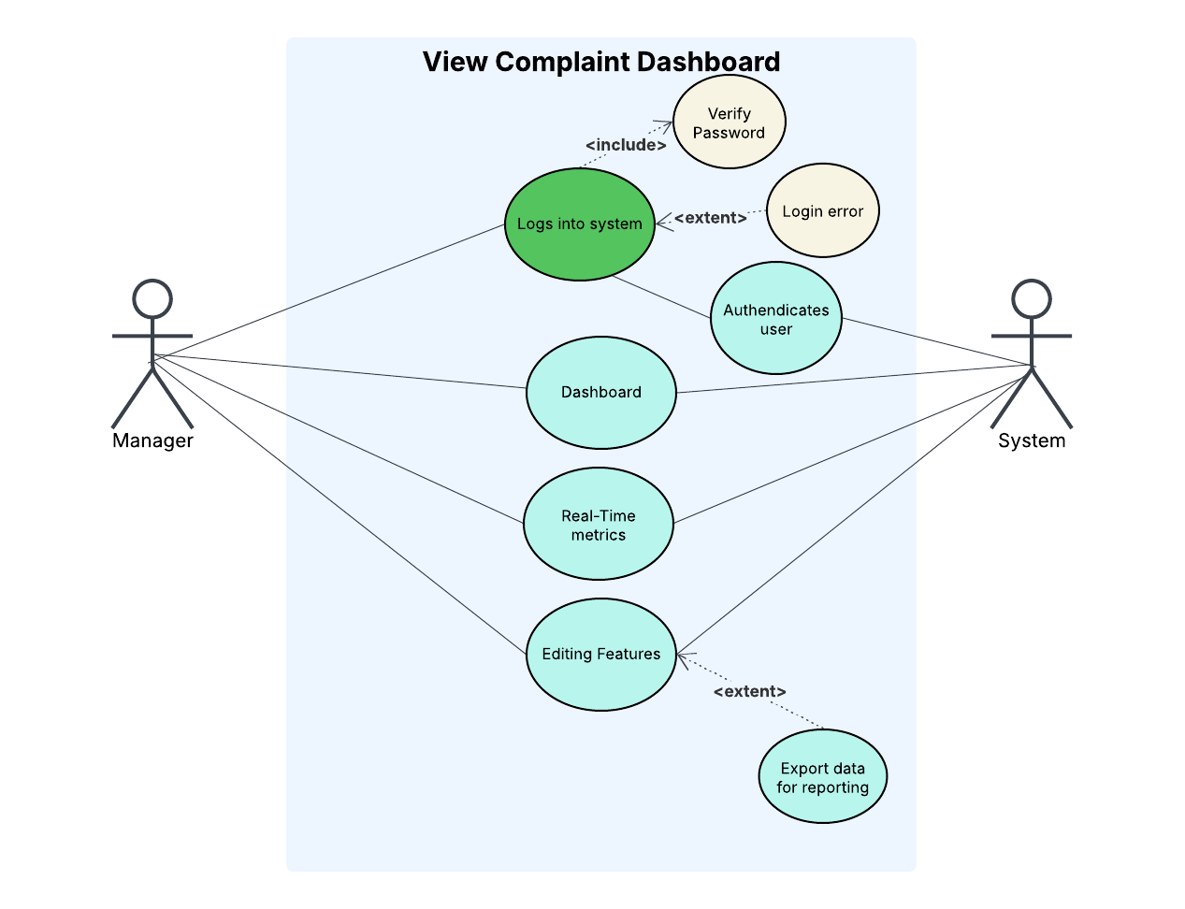

**Alternate Flow :**

* Role access denied if the logged-in user lacks manager privileges, system should display “Access to dashboard denied”
* If editing yields no results, system shows “No data available for the selected criteria or mode”.

**Related Functional Requirements :**

* FR-5 : Reporting Dashboard
* NFR-1 : Performance (real-time data loading)
* NFR-4 : Usability (editing)

**Frequency of Use :**

Typically used daily or weekly during of performance and reporting

**Revision History**

|  |  |  |  |  |
| --- | --- | --- | --- | --- |
| **S.no** | **Date** | **Author** | **Description** | **Status** |
| 1 | 26-06-2025 | Abdul Sohail | Business Analyst | Approved |
|  |  |  |  |  |
|  |  |  |  |  |